--Q1. List top 5 customers by total order amount.
--Retrieve the top 5 customers who have spent the most across all sales orders. Show CustomerID, CustomerName, and TotalSpent.

Select C.CustomerID,C.Name as CustomerName,T.TotalSpend from (Select top 5 SO.CustomerID, Sum(TotalAmount)as [TotalSpend] from SalesOrder SO
group by SO.CustomerID
order by 1 desc)
as T inner join Customer C on C.CustomerID =T.CustomerID

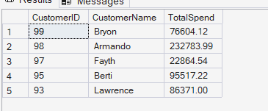

--Q2. Find the number of products supplied by each supplier.
--Display SupplierID, SupplierName, and ProductCount. Only include suppliers that have more than 10 products.

SELECT
s.SupplierID,
s.Name AS SupplierName,
COUNT(DISTINCT pod.ProductID) AS ProductCount
FROM dbo.Supplier s
JOIN dbo.PurchaseOrder po
ON s.SupplierID = po.SupplierID
JOIN dbo.PurchaseOrderDetail pod
ON po.OrderID = pod.OrderID
GROUP BY
s.SupplierID,
s.Name
HAVING COUNT(DISTINCT pod.ProductID) > 10;

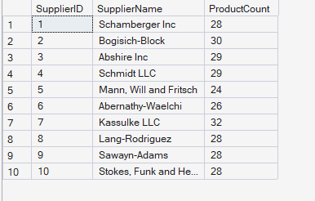

--Q3. Identify products that have been ordered but never returned.
--Show ProductID, ProductName, and total order quantity.

SELECT
p.ProductID,
p.Name AS ProductName,
SUM(sod.Quantity) AS TotalOrderedQuantity
FROM dbo.[Product] p
JOIN dbo.SalesOrderDetail sod ON p.ProductID = sod.ProductID
WHERE p.ProductID NOT IN (
SELECT DISTINCT ProductID
FROM dbo.ReturnDetail
)
GROUP BY
p.ProductID,
p.Name
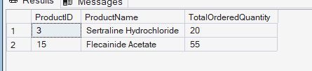
-- Q4. For each category, find the most expensive product.
--Display CategoryID, CategoryName, ProductName, and Price. Use a subquery to get the max price per category.

With CategoryWithMaxPrice AS (
Select MAX(Price) as maxprice,c.CategoryID,C.Name from [Product] p
inner join Category C on p.CategoryID =C.CategoryID
group by C.CategoryID,C.Name
)
Select CMP.CategoryID,CMP.Name as CategoryName ,p.Name as ProductName, CMP.maxprice from CategoryWithMaxPrice CMP
inner join [Product] p on p.CategoryID= CMP.CategoryID and p.Price=CMP.maxprice
order by CMP.CategoryID

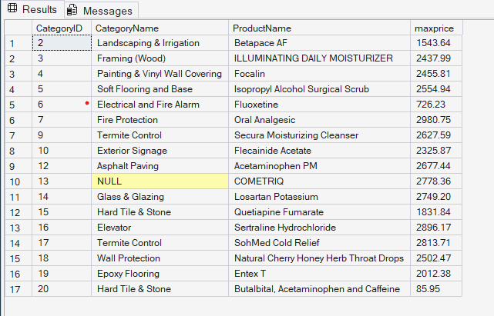

--Form Subquery
Select res.CategoryID,res.Name as CategoryName ,p.Name as ProductName, res.maxprice from (Select MAX(Price) as maxprice,c.CategoryID,C.Name from [Product] p
inner join Category C on p.CategoryID =C.CategoryID
group by C.CategoryID,C.Name)
as res inner join [Product] p on res.CategoryID=p.CategoryID and p.Price=res.maxprice


--Q5. List all sales orders with customer name, product name, category, and supplier.
--For each sales order, display:
--OrderID, CustomerName, ProductName, CategoryName, SupplierName, and Quantity.

SELECT
so.OrderID,cu.Name AS CustomerName, p.Name AS ProductName,cat.Name AS CategoryName,s.Name AS SupplierName,
sod.Quantity
FROM dbo.SalesOrder so
JOIN dbo.Customer cu ON so.CustomerID = cu.CustomerID
JOIN dbo.SalesOrderDetail sod ON so.OrderID = sod.OrderID
JOIN dbo.Product p ON sod.ProductID = p.ProductID
JOIN dbo.Category cat ON p.CategoryID = cat.CategoryID
JOIN dbo.PurchaseOrderDetail pod ON p.ProductID = pod.ProductID
JOIN dbo.PurchaseOrder po ON pod.OrderID = po.OrderID
JOIN dbo.Supplier s ON po.SupplierID = s.SupplierID
ORDER BY so.OrderID;
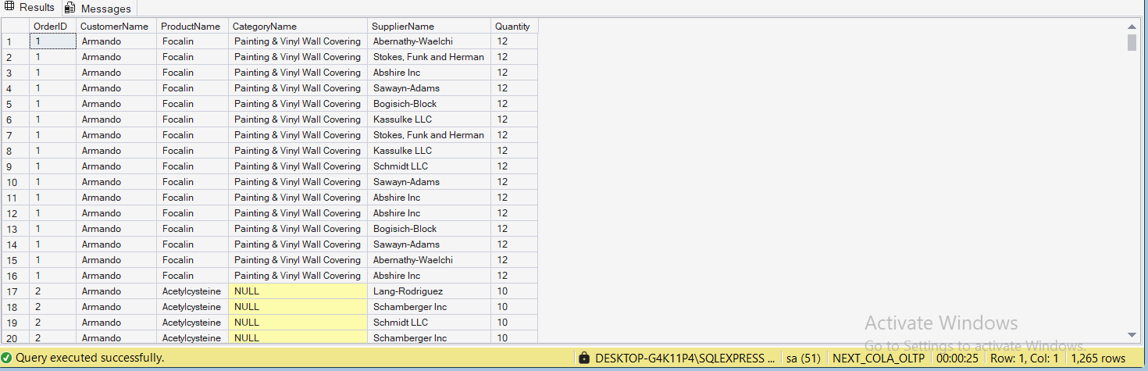

--Q6. Find all shipments with details of warehouse, manager, and products shipped.
--Display:
--ShipmentID, WarehouseName, ManagerName, ProductName, QuantityShipped, and TrackingNumber.

SELECT
sh.ShipmentID,
l.Name AS WarehouseName,
e.Name AS ManagerName,
p.Name AS ProductName,
sd.Quantity AS QuantityShipped,
sh.TrackingNumber
FROM dbo.Shipment sh
JOIN dbo.Warehouse w ON sh.WarehouseID = w.WarehouseID
Join dbo.[Location] l on l.LocationID=w.LocationID
JOIN dbo.Employee e ON w.ManagerID = e.EmployeeID
JOIN dbo.ShipmentDetail sd ON sh.ShipmentID = sd.ShipmentID
JOIN dbo.Product p ON sd.ProductID = p.ProductID
ORDER BY sh.ShipmentID;

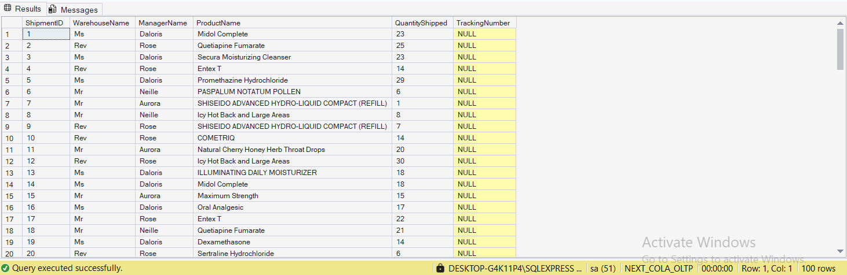

--Q7. Find the top 3 highest-value orders per customer using RANK(). Display CustomerID, CustomerName, OrderID, and TotalAmount.
WITH RankedOrders AS (
SELECT
c.CustomerID,
c.Name AS CustomerName,
so.OrderID,
so.TotalAmount,
RANK() OVER (
PARTITION BY c.CustomerID
ORDER BY so.TotalAmount DESC
) AS rnk
FROM dbo.Customer c
JOIN dbo.SalesOrder so ON c.CustomerID = so.CustomerID
)
SELECT
CustomerID,
CustomerName,
OrderID,
TotalAmount
FROM RankedOrders
WHERE rnk <= 3
ORDER BY CustomerID, rnk;

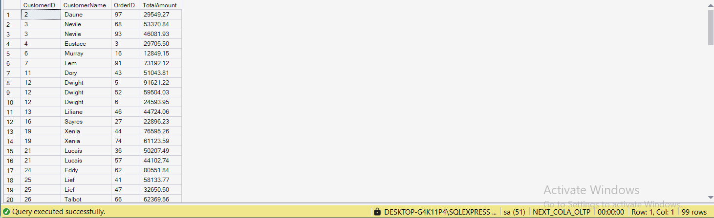

--Q8. For each product, show its sales history with the previous and next sales quantities (based on order date). Display
--ProductID, ProductName, OrderID, OrderDate, Quantity, PrevQuantity, and NextQuantity.

SELECT
p.ProductID,
p.Name AS ProductName,
so.OrderID,
so.OrderDate,
sod.Quantity,
null AS PrevQuantity,
null AS NextQuantity
FROM dbo.Product p
JOIN dbo.SalesOrderDetail sod ON p.ProductID = sod.ProductID
JOIN dbo.SalesOrder so ON sod.OrderID = so.OrderID
ORDER BY p.ProductID, so.OrderDate, so.OrderID;

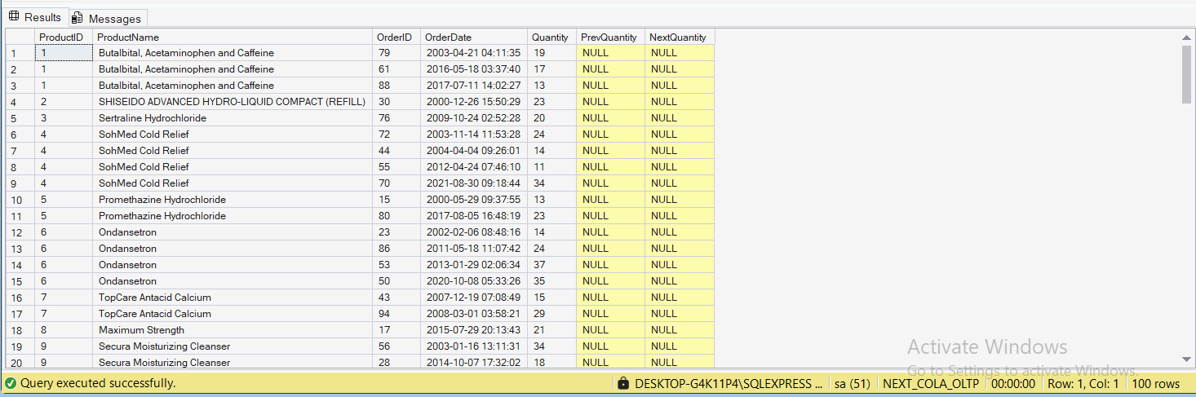

--Q9. Create a view named vw_CustomerOrderSummary that shows for each customer:
--CustomerID, CustomerName, TotalOrders, TotalAmountSpent, and LastOrderDate.

CREATE VIEW dbo.vw_CustomerOrderSummary
AS
SELECT
c.CustomerID,
c.Name AS CustomerName,
COUNT(so.OrderID) AS TotalOrders,
SUM(so.TotalAmount) AS TotalAmountSpent,
MAX(so.OrderDate) AS LastOrderDate
FROM dbo.Customer c
LEFT JOIN dbo.SalesOrder so ON c.CustomerID = so.CustomerID
GROUP BY
c.CustomerID,
c.Name;

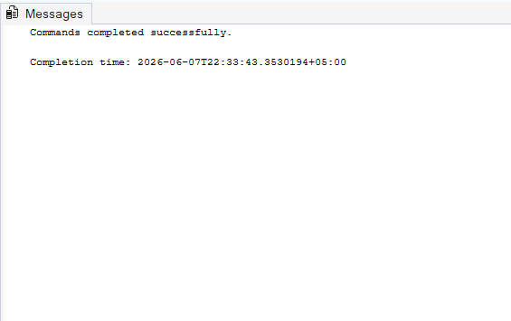

--Q10. Write a stored procedure sp_GetSupplierSales that takes a SupplierID as input and returns the total
--sales amount for all products supplied by that supplier.

Create PROCEDURE dbo.sp_GetSupplierSales
@SupplierID INT
AS
BEGIN
SET NOCOUNT ON;

IF NOT EXISTS (SELECT 1 FROM dbo.Supplier WHERE SupplierID = @SupplierID)
BEGIN
RAISERROR('Supplier with given ID does not exist.', 16, 1);
RETURN;
END

SELECT
s.SupplierID,
s.Name AS SupplierName,
COUNT(DISTINCT pod.ProductID) AS TotalProductsSupplied,
COUNT(DISTINCT so.OrderID) AS TotalSalesOrders,
SUM(sod.TotalAmount) AS TotalSalesAmount
FROM dbo.Supplier s
JOIN dbo.PurchaseOrder po ON s.SupplierID = po.SupplierID
JOIN dbo.PurchaseOrderDetail pod ON po.OrderID = pod.OrderID
JOIN dbo.SalesOrderDetail sod ON pod.ProductID = sod.ProductID
JOIN dbo.SalesOrder so ON sod.OrderID = so.OrderID
WHERE s.SupplierID = @SupplierID
GROUP BY
s.SupplierID,
s.Name;

END;



